Chiropractic Patient Information

Patient Name: ____________________________________________
Medical Conditions:
- Arthritis | - Asthma | - Atrial Fibrilation |  | - Cancer
- Diabetes | - Hashimotos Thyroid disease | - Heart disease |  | - History of ear infections
- Hyperlipidemia | - Hypertension | - Multiple Sclerosis |  | - Psychiatric Illness
- Stroke  - Other ________________ | - Rheumatoid Arthritis | - Sciatica |  | - Seizures
Surgeries:
- ACL repair | - Appendectomy | - Cardiovascular procedure |  | - Cervical Disc Procedure
- Discectomy | - Knee Replacement | - Laminectomies |  | - Lumpectomy
- Sinus | - Radical Prostatectomy | - Spinal Fusion |  | - Gall Bladder Removal
- Carpal Tunnel | - Hip Replacement | - Other_____________________
Social History:  Alcohol: □ Daily □ Weekly □ Occasionally □ Never  Caffeine: □ Daily □ Weekly □ Occasionally □ Never  Drugs: □ Daily □ Weekly □ Occasionally □ Never  Exercise: □ Daily □ Weekly □ Occasionally □ Never |  |  | OTC Stimulants: □ Daily □ Weekly □ Occasionally □ Never  Processed Food: □ Daily □ Weekly □ Occasionally □ Never  Soft Drinks: □ Daily □ Weekly □ Occasionally □ Never  Tobacco: □ Daily □ Weekly □ Occasionally □ Never
Family History: *Please indicate Father (F), Mother (M), Sibling (S), or Child (C)
- Auto Immune Conditions | - Cancer | - Cholesterol |  | - Diabetes
- Heart problems | - High blood pressure | - Psychiatric |  | - Stroke
Children:
- No 1 2 3 4 | 5 or more
Recreational Activities:
- Backpacking | - Biking | - Boating |  | - Football
- Golf | - Racket Ball/ Tennis | - Running |  | - Skiing
- Soccer | - Swimming | - Weight Lifting |  | - Walking
By using the key below, indicate on the body diagram where you are experiencing the following symptoms:
# = Numbness X = Burning / = Stabbing 0 = Pins & Needles + = Dull Ache T = Tightness
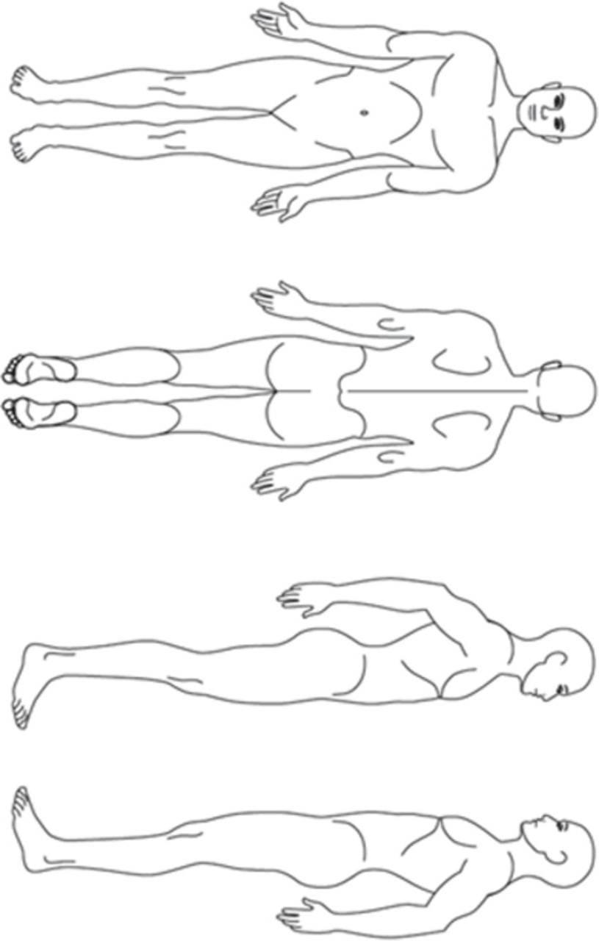

PLEASE CONTINUE TO PAGE 2=>

=>PAGE 2
NAME _____________________

Describe your symptoms:___________________________________________________________________________
__________________________________________________________________________________________________________________________
When did your symptoms start? Month_____________________ Day_________________ Year________________
How did your symptoms begin?______________________________________________________________________

What percentage of awake hours do you experience your symptoms?
□ 100% |  |  | □ 75% |  |  | □ 50% |  |  |  | □ 25%
What describes the nature of your symptoms?
- Sharp |  |  | - Dull ache |  |  | - Numb |  |  |  | - Shooting
- Burning |  |  | - Tingling |  |  | - Stabbing Tightness
How are your symptoms changing?
- Getting better |  |  | - Not changing |  |  | - Getting worse
During the past 4 weeks, indicate the average intensity of your symptoms: (0 = None to 10 = Unbearable)
- 0 None |  |  | - 1 |  |  | - 2 |  |  |  | - 3
- 4 |  |  | - 5 |  |  | - 6 |  |  |  | - 7
- 8 |  |  | - 9 |  |  | - 10 Unbearable
During the past 4 weeks, how much has pain interfered with your normal work (including both work outside the
home and housework):
- Not at all |  |  | - A little bit |  |  | - Moderately |  |  |  | - Quite a bit
- Extremely
During the past 4 weeks, how much of the time has your condition interfered with your social activities?
- All of the time |  | - Most of the time |  | - Some of the time |  |  | - A little of the time None of the time
In general, would you say your overall health right now is….
- Excellent |  | - Very good |  | - Good |  |  |  |  | - Fair Poor
Who have you seen for your symptoms:
- No one | - Other Chiropractor |  |  |  | - Medical Doctor |  |  | - Physical Therapist ❑ Other
What treatment did you receive for your symptoms?
- Adjustments |  | - Physical Therapy |  |  | - Medication |  |  | - Surgery ❑ Other
When did you receive this treatment?
- In the last month |  |  | - 2 – 3 months ago |  |  | - 3 – 6 months ago |  |  |  | - 6 months to 1 year ago
- 1 – 2 years ago |  |  | - 2 – 5 years ago |  |  | - 5 – 10 years ago
What tests have you had for your symptoms?
- X-rays |  |  | - MRI |  |  | - CT Scan |  |  |  | - Other
When were these tests done?
- In the last month |  |  | - 2 – 3 months ago |  |  | - 3 – 6 months ago |  |  |  | - 6 months to 1 year ago
- 1 - 2 years ago |  |  | - 2 – 5 years ago |  |  | - 5 – 10 years ago
Have you had similar symptoms in the past?
❑ Yes ❑ No

Current medications, including dosage if known. If none, check here: ❑

1) 3)

2) 4)

List any known allergies. If none, check here: List supplements, herbs, vitamins _________________________________ _____________________

